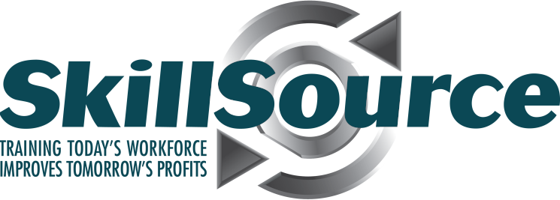 Matched Investment Savings Account (MISA)

New Account Authorization

Participant Name: _______________________________________________________________

## Participant Address: _______________________________________________________________

Participant Phone Number: _______________________________________________________

SkillSource Authorized Representative:_____________________________________________

SkillSource Representative Address: ______________________________________________

SkillSource Representative Phone Number: ________________________________________

The individual listed above is approved and eligible to participate in the Matched Investment Savings Account (MISA) program sponsored by SkillSource. In addition to providing the MISA New Account Authorization form at account opening, the participant will provide Umpqua Bank with valid identification required to open an account.

Please expect an email from Umpqua Bank and a follow up via preferred method of communication notifying you your account has been successfully opened. It is important to make your first deposit within 30 days of Umpqua’s notification of account opening.

The participant opening the account must sign this eligibility form authorizing Umpqua Bank to release information on his/her MISA account to their SkillSource Authorized Representative. The authorized representative will use the information Umpqua Bank provides to monitor the participant’s continued eligibility for MISA savings participation and matched funds in order to assist the participant in reaching their savings goals.

The participant recognizes that no funds can be withdrawn from the account without the completed MISA Withdrawal Authorization form signed by an authorized SkillSource representative. The participant must provide the completed withdrawl form to Umpqua Bank.

This Authorization is valid until: mm/dd/yyyy

___________________________________________________________________________________Signature of Account Owner (Participant) Date

___________________________________________________________________________________Signature of Authorized Representative Date

Approved by: [Printed name of Authorized Representative]